# India's Space Odyssey: ISRO's Remarkable Contributions to Science and Humanity

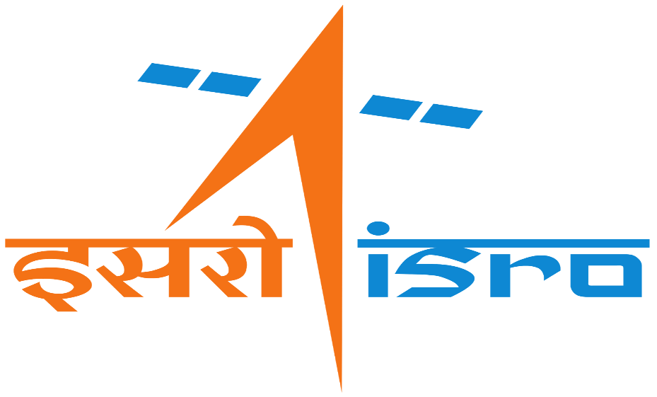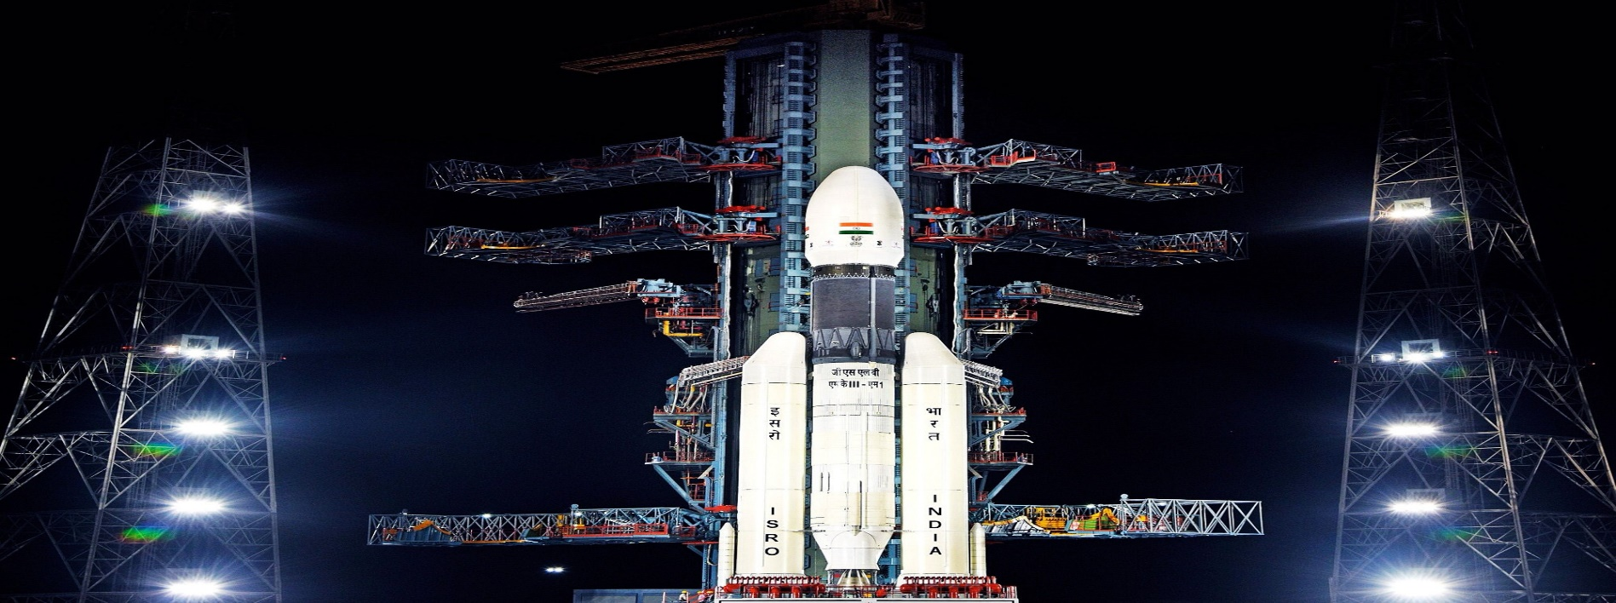

# Introduction:

India, a nation known for its rich cultural heritage, has emerged as a formidable player in the realm of space technology. The Indian Space Research Organisation (ISRO) has achieved numerous milestones, contributing significantly to the country's future and leaving an indelible mark on the global space community. In this blog post, we will delve into the emerging space technology in India and its potential benefits for India's future. We will also explore some notable missions conducted by ISRO, with a focus on the recently launched Chandrayaan-3 mission. Finally, we will discuss how India's space missions are not only crucial for national development but also offer substantial benefits for humanity as a whole.

## 1. Emerging Space Technology in India and Its Significance for India's Future:

India's foray into space technology has witnessed tremendous growth in recent decades. ISRO has been at the forefront, driving advancements in satellite technology, remote sensing, space exploration, and satellite-based communication systems. The development of indigenous launch vehicles, such as the Polar Satellite Launch Vehicle (PSLV) and the Geosynchronous Satellite Launch Vehicle (GSLV), has been a game-changer for the country. These advancements have bolstered India's capabilities in communication, weather forecasting, disaster management, national security, and much more. Moreover, the successful execution of the Mars Orbiter Mission (MOM) in 2014 showcased India's technological prowess, placing it among a select group of nations that have successfully reached the Red Planet. This progress in space technology sets a solid foundation for India's future endeavours, propelling the nation to new heights in scientific research and technological innovation.

## 2. Notable Missions of ISRO:

**a) Chandrayaan-1:** Launched in 2008, Chandrayaan-1 was India's first lunar mission. It played a pivotal role in discovering water molecules on the Moon's surface and mapping the lunar terrain using the Moon Mineralogy Mapper (M3). This mission marked a significant milestone for ISRO and set the stage for future lunar explorations.

**b) Mars Orbiter Mission (MOM):** Also known as Mangalyaan, MOM was launched in 2013 and successfully inserted the Mars Orbiter spacecraft into the Martian orbit in 2014. This made India the first Asian nation to reach Mars and the first in the world to do so on its maiden attempt. The mission provided valuable insights into the Martian atmosphere and its evolution, enhancing our understanding of the Red Planet.

**c) GSLV Mk III:** The Geosynchronous Satellite Launch Vehicle Mark III, launched in 2019, is India's most potent launch vehicle to date. It has the capability to place heavier satellites into orbit, thus reducing the dependence on foreign launch services. The successful launch of the Chandrayaan-2 missions, aimed at lunar exploration, further demonstrated the reliability and strength of the GSLV Mk III.

## 3. Key Points on Chandrayaan-3 Mission:

ISRO's Chandrayaan-3 mission, scheduled for launch in 2023, is an ambitious endeavour to return to the Moon's surface and carry out a soft landing. It is a follow-up to the Chandrayaan-2 mission, which faced challenges during its landing phase. Chandrayaan-3 aims to build upon the successes of its predecessor and validate the technologies required for future lunar missions. The mission will deploy a lander and rover to explore the lunar surface, collect valuable data, and conduct experiments to enhance our understanding of the Moon's geology, potential resources, and its connection to Earth's evolution.

## 4. India's Space Missions and Their Impact on Humanity:

India's space missions extend beyond national boundaries, offering immense benefits to humanity as a whole. Here are a few significant points highlighting their importance:

**a) Global Collaboration:** ISRO actively engages in international collaborations, fostering partnerships with space agencies around the world. These collaborations facilitate knowledge sharing, joint research, and technological advancements, contributing to scientific progress on a global scale.

**b) Disaster Management and Communication:** ISRO's remote sensing satellites provide crucial data for disaster management, enabling early warning systems, rapid response, and relief operations during natural disasters. Satellite-based communication systems also play a vital role in connecting remote regions and bridging the digital divide.

**c) Climate Change Monitoring:** ISRO's satellites help monitor climate patterns, assess environmental changes, and contribute to efforts aimed at combating climate change. Accurate weather forecasting, disaster prediction, and monitoring agricultural activities support sustainable development and enable informed decision-making.

**d) Inspiring Future Generations:** India's space missions have sparked widespread interest in science and technology, motivating young minds to pursue careers in STEM fields. This enthusiasm for space exploration nurtures a generation of innovators and problem-solvers who will shape the future of humanity.

## Conclusion:

ISRO's remarkable achievements in space technology have positioned India as a global leader in the field. The emerging space technology in India holds great promise for the nation's future, empowering it to tackle critical challenges and drive scientific and technological advancements. As ISRO continues to push boundaries with missions like Chandrayaan-3, India's contributions to space exploration and research are set to further benefit not only the nation but also humanity as a whole.